WorkshopPLUS – Power Apps for Power User 1 Day

Module 4.1: Add compare screens and add/remove gallery controls

Student Lab Manual

**Conditions and Terms of Use**

Microsoft Confidential

This training package is proprietary and confidential, and is intended only for uses described in the training materials. Content and software is provided to you under a Non-Disclosure Agreement and cannot be distributed. Copying or disclosing all or any portion of the content and/or software included in such packages is strictly prohibited.

The contents of this package are for informational and training purposes only and are provided "as is" without warranty of any kind, whether express or implied, including but not limited to the implied warranties of merchantability, fitness for a particular purpose, and non-infringement.

Training package content, including URLs and other Internet Web site references, is subject to change without notice. Because Microsoft must respond to changing market conditions, the content should not be interpreted to be a commitment on the part of Microsoft, and Microsoft cannot guarantee the accuracy of any information presented after the date of publication. Unless otherwise noted, the companies, organizations, products, domain names, e-mail addresses, logos, people, places, and events depicted herein are fictitious, and no association with any real company, organization, product, domain name, e-mail address, logo, person, place, or event is intended or should be inferred.

**Copyright and Trademarks**

© 2020 Microsoft Corporation. All rights reserved.

Microsoft may have patents, patent applications, trademarks, copyrights, or other intellectual property rights covering subject matter in this document. Except as expressly provided in written license agreement from Microsoft, the furnishing of this document does not give you any license to these patents, trademarks, copyrights, or other intellectual property.

Complying with all applicable copyright laws is the responsibility of the user. Without limiting the rights under copyright, no part of this document may be reproduced, stored in or introduced into a retrieval system, or transmitted in any form or by any means (electronic, mechanical, photocopying, recording, or otherwise), or for any purpose, without the express written permission of Microsoft Corporation.

For more information, see Use of Microsoft Copyrighted Content at

<http://www.microsoft.com/en-us/legal/intellectualproperty/Permissions/default.aspx>

DirectX, Hyper-V, Internet Explorer, Microsoft, Outlook, OneDrive, SQL Server, Windows, Microsoft Azure, Windows PowerShell, Windows Server, Windows Vista, and Zune are either registered trademarks or trademarks of Microsoft Corporation in the United States and/or other countries. Other Microsoft products mentioned herein may be either registered trademarks or trademarks of Microsoft Corporation in the United States and/or other countries. All other trademarks are property of their respective owners.

Contents

Lab 4.1: Add compare screens, add/remove gallery controls, and test the App 5

Exercise 1: Add Compare Screen 6

Task 1: Add screen 6

Task 2: Configure the gallery 12

Task 3: Remove and add controls to the gallery 13

Task 4: Highlight the selected device 14

Task 5: Add an icon to navigate to the first screen 15

Task 6: Test the app 16

# Lab 4.1: Add compare screens, add/remove gallery controls, and test the App

**Introduction**In this lab, you will perform the actions necessary for building Power Apps by adding a compare screen, adding/removing gallery controls, and testing the app.

**Objectives**

After completing this lab, you will be able to:

#### Add Compare Screen

#### Remove and add controls to the gallery

#### Highlight selected device

#### Add icon to navigate

#### Test the app

**Prerequisites**

Ensure you are using the “Incognito” or “InPrivate” browsing session of your modern browser.

Additionally, use the latest version of [Microsoft Edge](https://support.microsoft.com/en-us/help/4501095/download-the-new-microsoft-edge-based-on-chromium) (aka Edge Chromium) for the best performance.

**Estimated time to complete this lab**

30 mins

#### Scenario

The organization wishes to build apps using the PowerApps platform to take advantage of **No Code/Low Code** application development in the cloud. As part of this effort, you are required to add compare screens, add/remove gallery controls, manipulate the navigation, and test the functionality of your app.

## Exercise 1: Add Compare Screen

The second screen is where users compare the selected devices and then choose the one they wish to submit for approval.

This screen includes:

* A back button for navigating back to the main screen.
* A list of selected devices for comparison (carried over from the main screen).
* Additional details for each device
* Highlighting the selected device

In a subsequent lab, you will create the database entities to store device orders and add an edit form to this screen to enter additional information and submit the request.

### Task 1: Add screen

1. From the ribbon select **Home**, **New screen**, and then **Blank**.

2.

Rename the screen to **Compare Screen**.

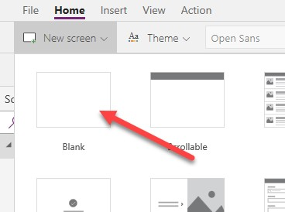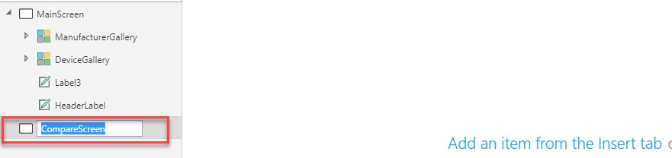

3. From the left tree view, select **MainScreen**, click on the **Insert** tab on the ribbon and then select **Button** to add a button to the screen.

4.

Place the button in the bottom right corner.

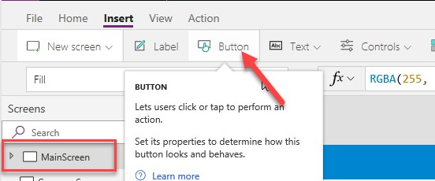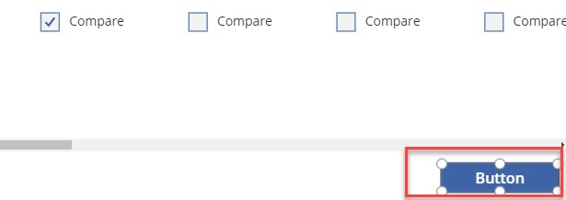

1. Set the button’s **Text** property to

"Compare " & CountRows(CompareList) & " item(s)"

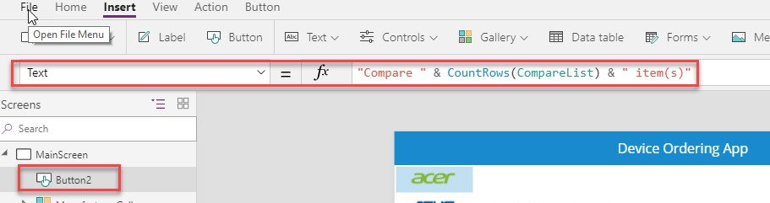

1. Resize the button so that the text fits without wrapping.

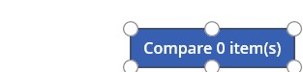

1. Select the button and set its **DisplayMode** property to **Disabled** if there are no items in CompareList

If(CountRows(CompareList) > 0, DisplayMode.Edit, DisplayMode.Disabled)

8.

Unselect all devices - notice how the **Compare** button is grayed-out.

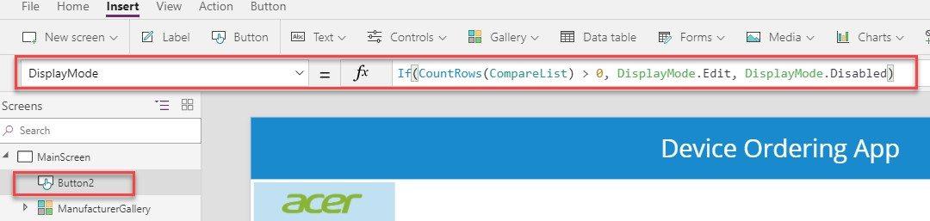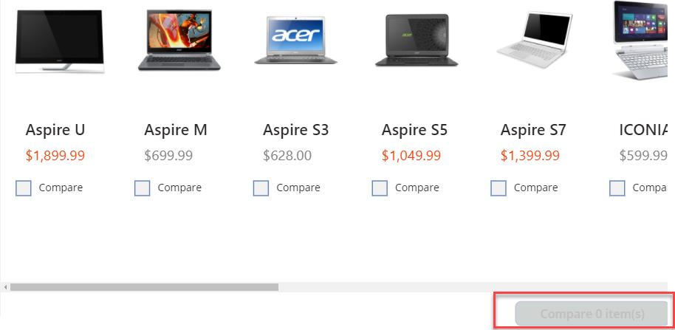

1. Select the **Compare** button and copy (Ctrl-C) it.
2. Paste (Ctrl-V) the **Compare** button on the same screen.

11.

Position it to the left of the

**Compare** button.

12.

Change the **Text**

property to Clear selection.

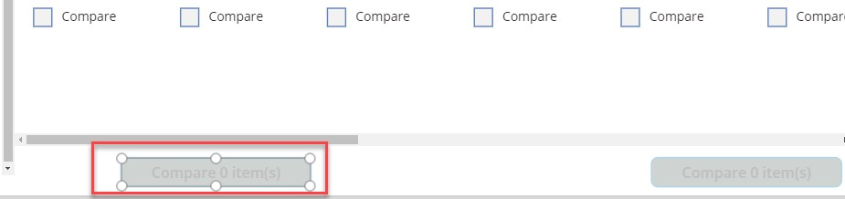

1. Set the **OnSelect** property for this button to Clear(CompareList).

This will remove all the items in the **CompareList** collection.

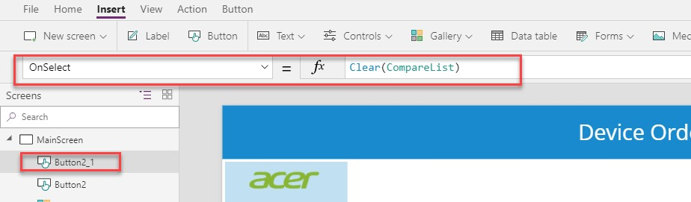

1. Select the **Compare** button, click on the **Action** tab, and select **Navigate**.

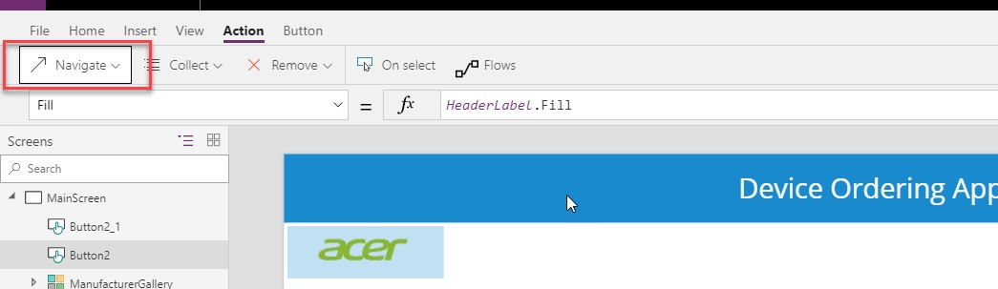

1. Select **CompareScreen** from the drop-down and **ScreenTransition.None** for transition type.

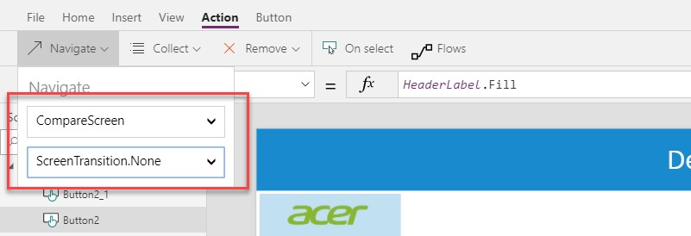

1. Click **Preview**.
2. Select a couple of devices and click the **Compare** button. Verify that it takes you to the second screen.

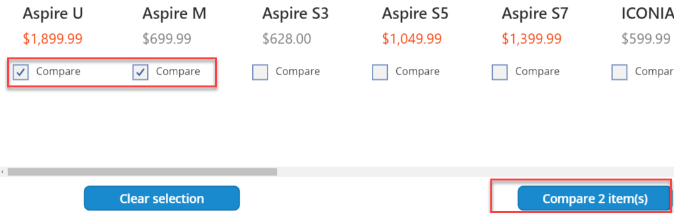

1. Navigate to the new empty screen. Close the preview.

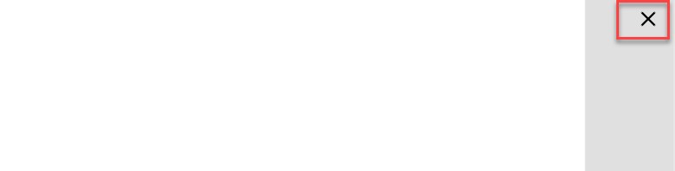

1. Go to **MainScreen** in the left navigation.
2. Select both the **UserLabel** and **HeaderLabel**, right-click, and select **Group**.

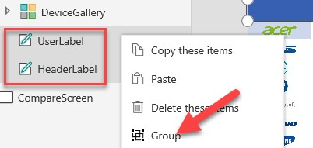

1. Rename the group **Header**.
2. Click on the **…** button of the **Header** and select **Copy**.

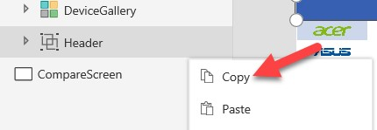

1. Right-click on **CompareScreen** and select **Paste**.

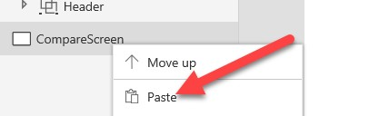

1. Select the **Header** group, click on the **Align** buttonlocated in the **Home** tab, and select **Align top**.

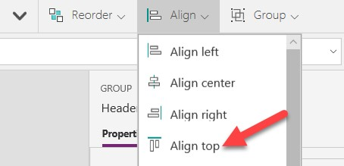

1. The **Header** in **CompareScreen** should look like the image below:

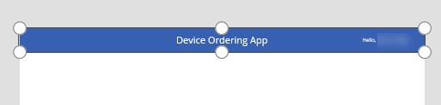

1. Copy **DeviceGallery** from **MainScreen** and paste it in **CompareScreen**.
2. Move the gallery to the left edge of the screen. Align the top of the gallery to be just under the header banner. Use the right drag handle to reduce the width of the gallery and create space for a data entry form on the right of the screen. You will insert a **Form** control here.

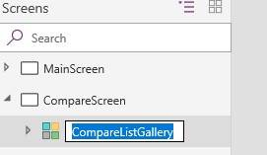

28.

Rename this gallery to

**CompareListGallery**

.

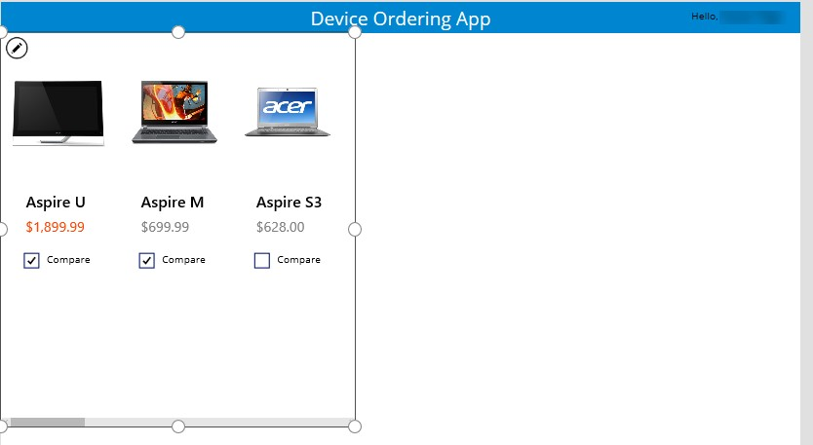

### Task 2: Configure the gallery

In this task, you will configure the gallery to show devices that were selected from the comparison gallery on **MainScreen**.

* 1. Select the new **CompareListGallery**.
  2. Select **Items** in the property drop-down list and change the data source in the formula bar to **CompareList**.

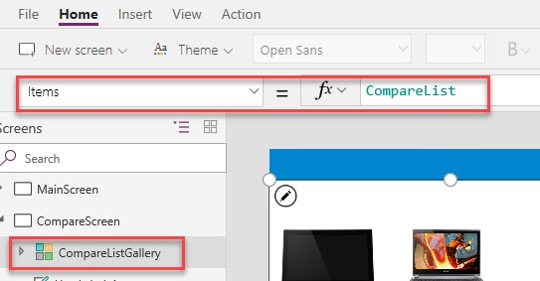

* 1. The gallery will now show the selected items from the **MainScreen**.

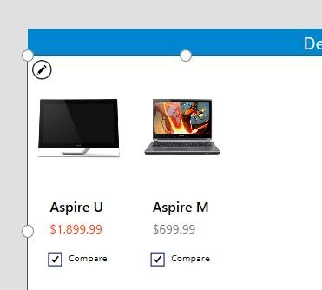

### Task 3: Remove and add controls to the gallery

In the second screen, we are selecting a given item to get approved, so we do not need a **Compare** checkbox.

1. Select the **Compare** checkbox on the left-most template cell and press the **Delete** key to delete the checkbox.
2. Now add a few labels to display additional attributes about the device. A good way to do this is to copy-paste an existing label. Select the first label in the gallery that is displaying the device name, copy (Ctrl-C), and paste (Ctrl-V).
3. Move the new label so that it is just below the price. Set the **Text** property to **ThisItem.ManufacturerName**.

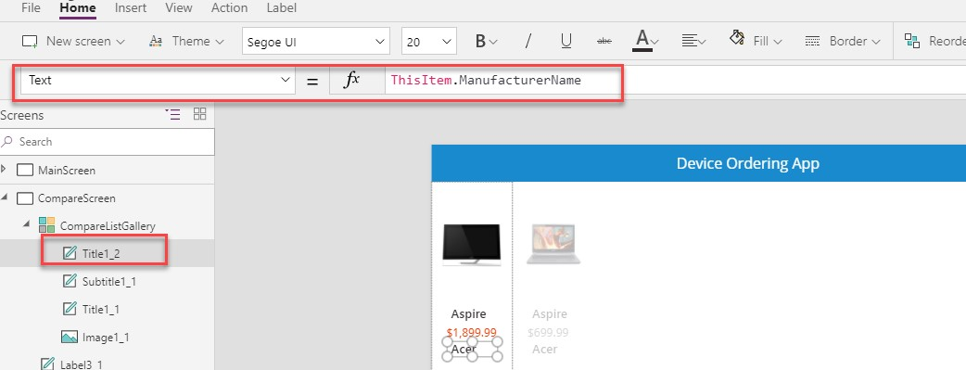

1. Use the ribbon to change the font-weight from **Semi bold** to **Normal** and change the **size** property from **20** to **18**.

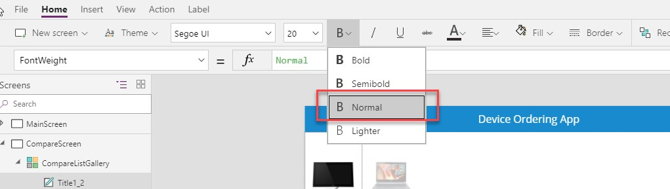

1. Copy-paste this label and move the new fourth label below the third label. Set its **Text** property to **ThisItem.Memory**.

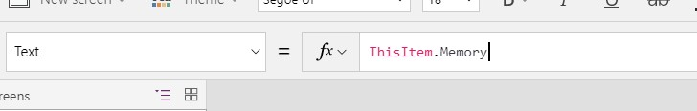

1. Repeat this and add text boxes to display the additional device properties, such as processor, storage, and screen size. Feel free to customize the labels by changing their size, color, fill, and font-weight properties.

**Note**: For this lab, you may add one or two of these additional properties and skip adding the additional device properties in order to save time.

### Task 4: Highlight the selected device

Like the behavior in the manufacturer gallery in the first screen, use the **TemplateFill** property to specify a highlight color for the selected item.

1. Select **CompareListGallery**.
2. With the whole gallery selected, set **TemplateFill** property to If(ThisItem.IsSelected,ColorFade(HeaderLabel.Fill,75%))

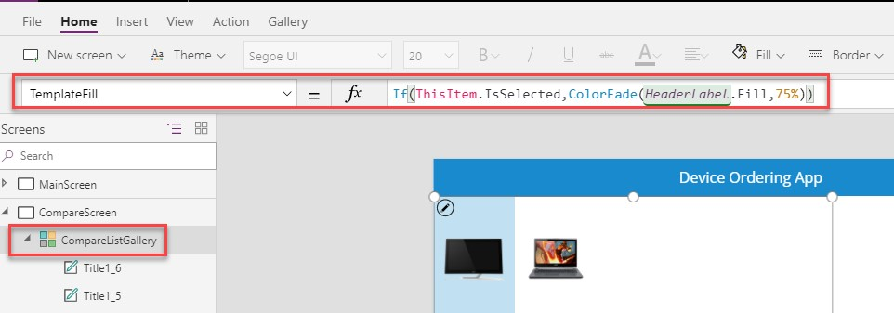

This is conditionally setting a fill color if the cell is selected.

You could have set a specific color or RGB value, but we recommend using the **ColorFade** function so that it matches the header label with a 75% fade. If you change the fill color of the header label, this template fill color will automatically change.

1. Click a few different items in the gallery. Notice that the selected item is highlighted in a light blue color.

### Task 5: Add an icon to navigate to the first screen

1. Select **CompareScreen**.
2. Click on **Insert**, select **Icons** and then select **Left**. Position it in the upper left corner of the screen.

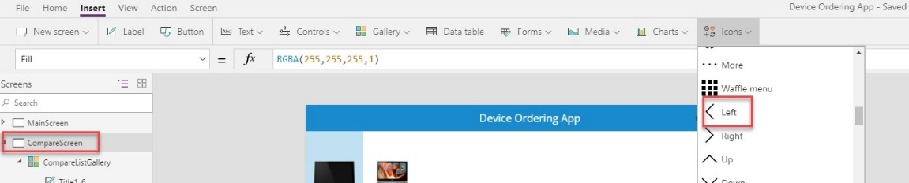

1. Select the arrow control and change the **Color** property to **White**. You can change this in the formula bar or through the properties pane on the right.

4.

Move the arrow to the top-left corner.

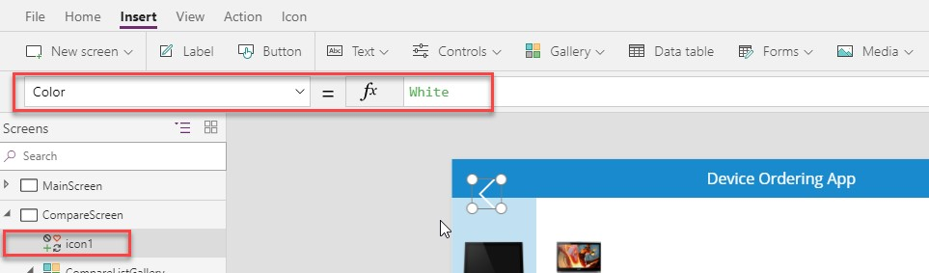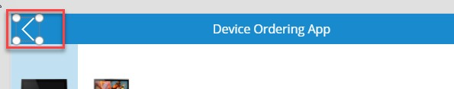

5. Set the **OnSelect** action for the icon to Back(). This will cause navigation to go back to the previous screen.

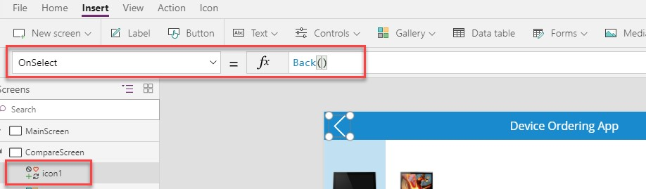

**Optional UI enhancement:**

Add padding around the icon using the properties pane. Set the padding values to 10 each for **Top**, **Bottom**, **Left**, and **Right**. This will make the icon look smaller but have a larger hit target for the click action. This is a good pattern to use for most icons.

### Task 6: Test the app

Save the app by selecting **File** à **Save**. It's a good idea to save your app regularly.

**Note**: You can also test your app on the canvas by holding down the **Alt** key to activate buttons and other controls, as well as double-clicking to type into controls.

1. Go to **MainScreen** and **Preview** the app by clicking on the **Play** button on the top right.

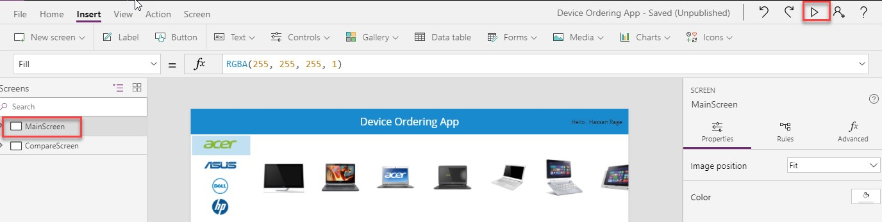

1. Deselect if there are any checked devices.
2. Select **Microsoft** in the left bar to show a filtered set of devices.
3. Check the **Compare** box on a few devices on the main screen from a few different manufacturers.
4. Click the **Compare** button to navigate to the compare screen.

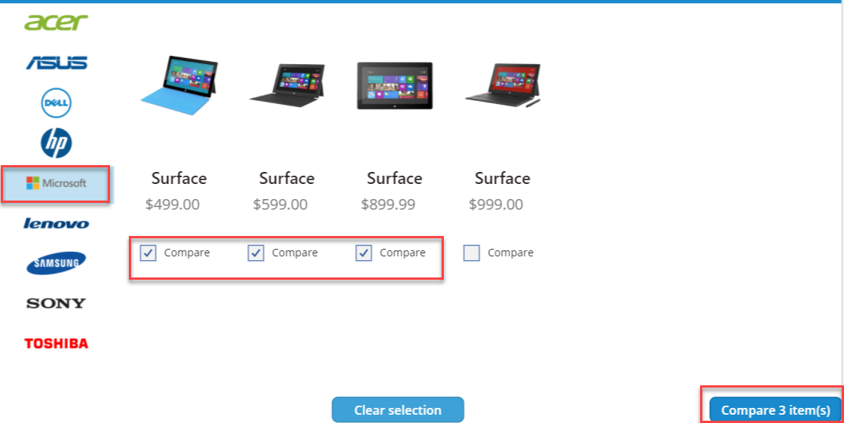

1. Tap or click on different devices in the gallery and verify that the selection highlight works.
2. Select the **Back** button and confirm that you get back to the main screen.

8.

Select **Clear selection**.

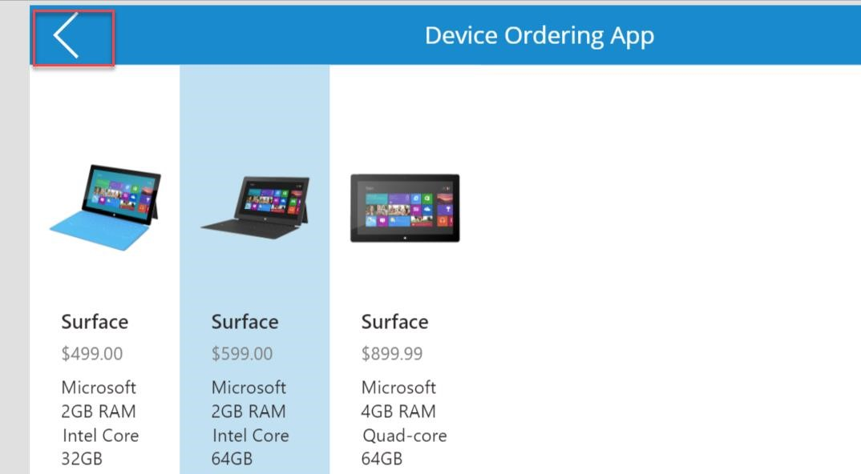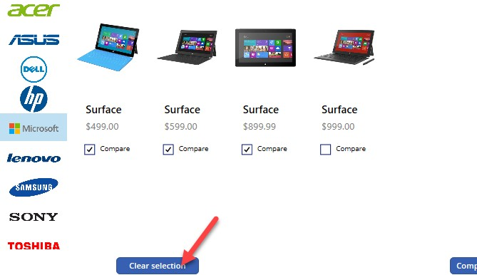

1. The **CompareList** will clear, and the **Compare** button will become disabled.

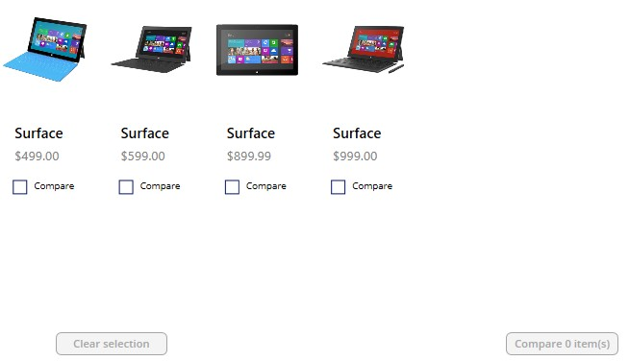

1. Close the preview.